

Khozama Obeidat

Coding academy by orange

CodingA+

Coding Learning Hub

Table of Contents

Introduction 3

Purpose 3

Features 3

Technologies 3

Landing Page 4

The Feed Page 5

Table of Figures

Figure 1 - Landing Page 4

Figure 2 - Feed 5

# Introduction

CodingA+ is a learning hub designed and built to match the concept of the Coding Academy by Orange, where all the tools needed to support the learning process come together under one name and platform.

CodingA+ provides several features to help organize and manage the various learning processes, helping the trainees, the mentors, as well as the managers to enhance the quality of different aspects of the process including communication, accessibility, and time management.

# Purpose

This learning hub is a technology-rich learning environment with both physical and virtual components that provide formal and informal opportunities for learners to come together with peers, teachers, and other experts in their field.

This platform comes as a solution for various communication and convenience issues rising with the rise of demand on learning coding and programming technologies in our day and time. As a trainee of this academy, I offer to provide a simple solution for all the issues mentioned above.

# Features

This learning platform provide the following main features:

* Managing trainees
* Managing mentors
* Managing projects
* Managing tasks and assignments.
* Managing the communication process.

And many other features that will be explained in the upcoming sections.

# Technologies

The main technologies and tools used in the development of this platform:

* Html, CSS, Bootstrap, and React framework for the front-end part.
* Firebase and firestore for the database and back-end part.
* React Hooks.
* React Authentication.
* The Visual Studio Code Editor.
* Trello for project management.

# Landing Page

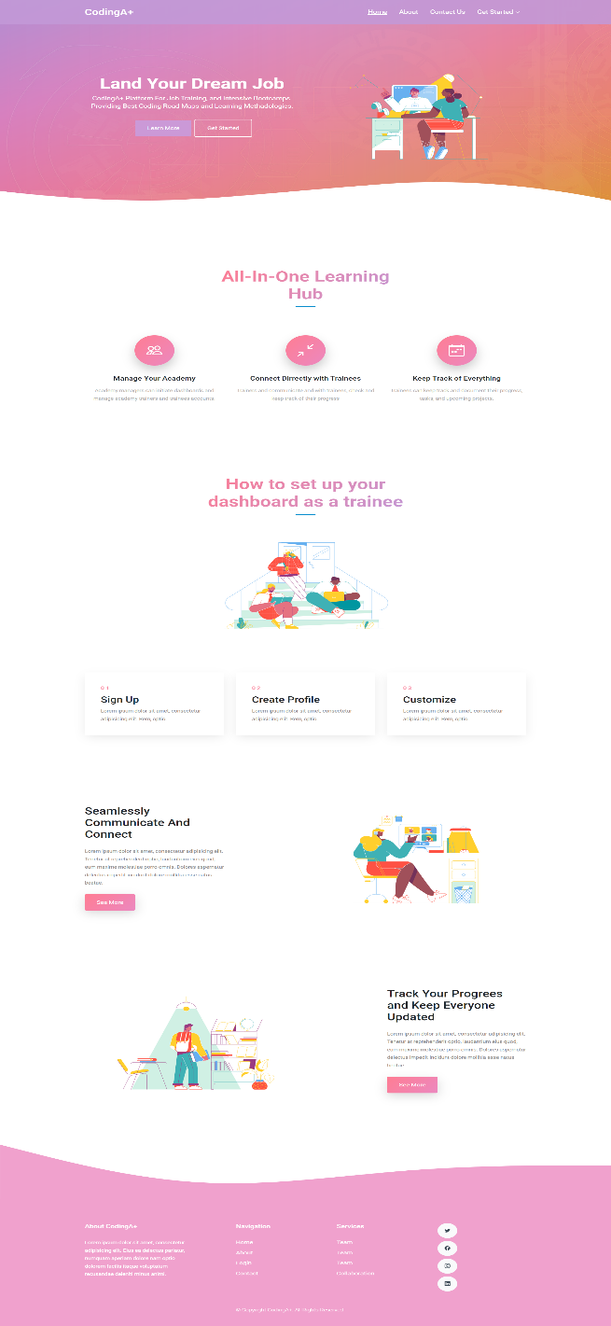This is the landing page of this platform; this is the first page that the user is going to see.

Figure - Landing Page

This page includes a brief description about the platform, main features, and action buttons guiding the user to different parts of the platform.

# The Feed Page

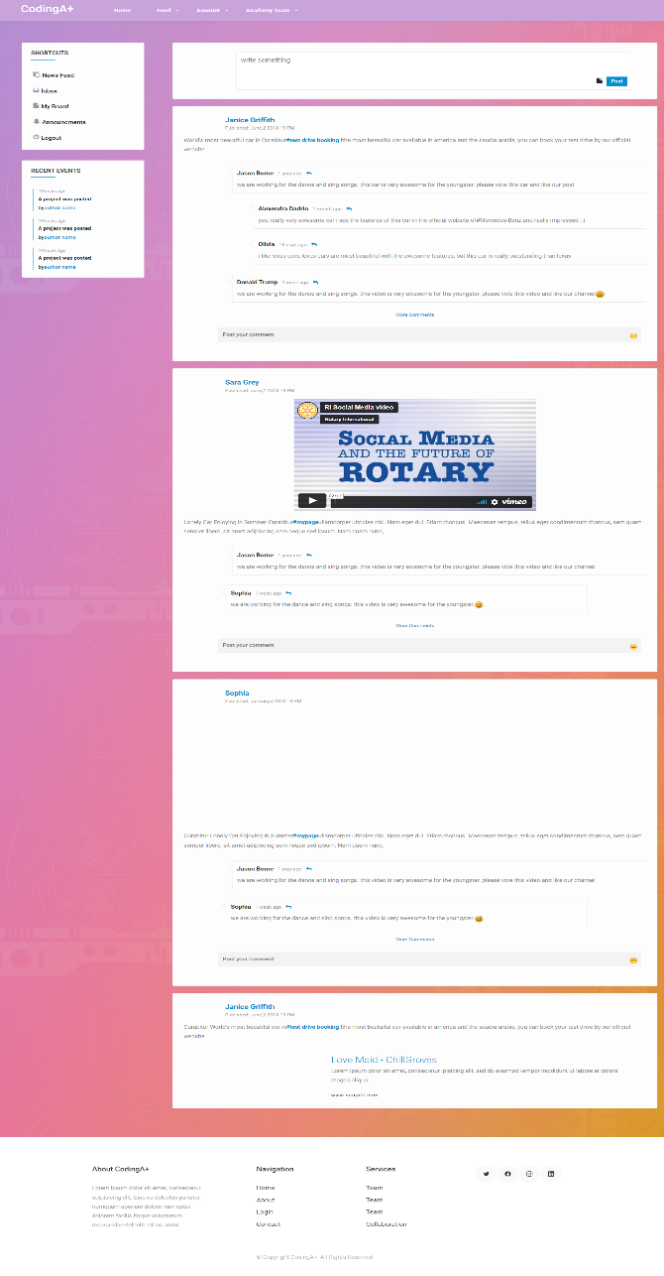This page is one of the main pages in the website where all users will have access to.

Figure - Feed

Users will be able to access their profiles and board, as well as add posts and comments on each other posts.

# Trainer’s Board

This dashboard will be viewed and managed by the trainers, they will be able to view and manage the projects, tasks, and submissions.

### Add New project brief

Through this page trainers will be able to add and publish new project brief providing the information needed about the project.